MSDS680_S40_ Machine Learning
Week 8 capstone project
Ilse Severance
2026
Week 8 Capstone Project: Technical Report - Predicting Loan Default
- Introduction
Objective: Develop a machine learning model to predict loan default using a dataset of 255,347 loan applications. Features include borrower demographics, financial indicators, and loan characteristics.
Business Motivation: Identify high risk borrowers to reduce financial losses and support risk-based decision making.
Stakeholder Needs: Credit risk analysts identify high risk borrowers, loan officers use risk scores to prioritize applications, and management monitors portfolio risk using predicted probabilities instead of binary outcomes
Evaluation Metrics: ROC-AUC ≥ 0.80, F1-score ≥ 0.75, Recall (default class) ≥ 0.75.

- Methodology Overview
The goal of this study was to develop a machine learning model to predict loan default using a financial dataset. The chosen dataset had 255,347 loan applications. The dataset included borrower demographics, financial indicators, and loan characteristics, such as Age, Income, CreditScore, LoanAmount, DTIRatio, EmploymentType, and LoanPurpose.
The modeling approach followed these main steps:
- EDA and Data Understanding: Exploring distributions, correlations, and missing values.
- Data Preprocessing & Feature Engineering: encoding, scaling, and generating new features.
- Model Development: baseline, candidate models, hyperparameter tuning, final model selection.
- Model Evaluation: test set evaluation, error analysis, feature importance, and deployment considerations.

- Model Development
  - Model Comparison
Five classification models were evaluated for loan default prediction: Naive Bayes, Logistic Regression, Decision Tree, Random Forest, and Gradient Boosting.

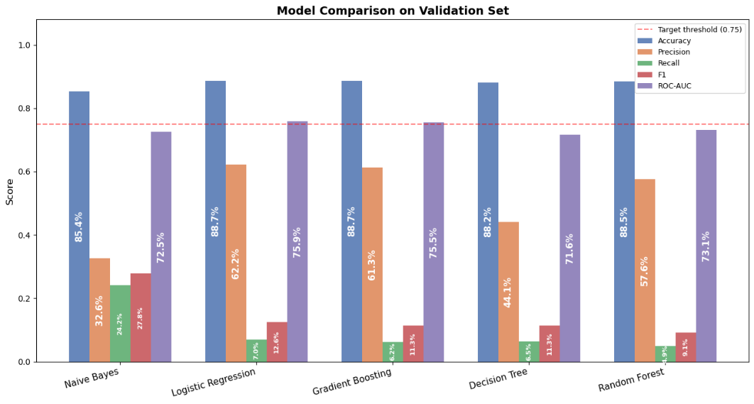
Figure 1. Model Comparison on Validation Set

As shown in Figure 1, logistic Regression and Gradient Boosting achieved the highest overall accuracy (0.887), with Logistic Regression also obtaining the highest ROC-AUC score (0.759), indicating the strongest ability to rank borrowers by default risk. Naive Bayes produced the highest recall (0.242) and F1-score (0.278), identifying more default cases than the other models but with lower overall accuracy. Tree based models, including Decision Tree and Random Forest, showed similar accuracy levels (0.882–0.885) but struggled with recall, reflecting the impact of class imbalance on detecting default cases. Overall, Logistic Regression and Gradient Boosting provided the best overall predictive performance, while Naive Bayes was more effective at identifying default cases, highlighting a trade-off between overall accuracy and minority class detection.
- Hyperparameter Tuning
For hyperparameter tuning, Random Forest and Gradient Boosting were selected as the top models because ensemble tree methods are suited for structured financial data and can capture complex non-linear relationships and feature interactions. Random Forest improves stability and reduces overfitting through bagging and random feature selection, while Gradient Boosting sequentially corrects errors from previous trees, often leading to stronger predictive performance on tabular datasets. These characteristics make both models strong candidates for further optimization and improved default prediction.
  - Final Model Selection
Figure 2 illustrates that the tuned Random Forest achieved a cross-validation AUC of 0.742, while the tuned Gradient Boosting reached a slightly higher cross-validation AUC of 0.751. On evaluation, the tuned Random Forest produced accuracy of 0.739, recall of 0.602, F1-score of 0.349, and ROC-AUC of 0.749, whereas the tuned Gradient Boosting achieved accuracy of 0.887, recall of 0.061, F1-score of 0.110, and ROC-AUC of 0.757. Although Random Forest improved recall, Gradient Boosting (tuned) was selected as the final model due to its higher overall accuracy and ROC-AUC, as well as its suitability for probability risk scoring and interpretability in financial risk assessment.

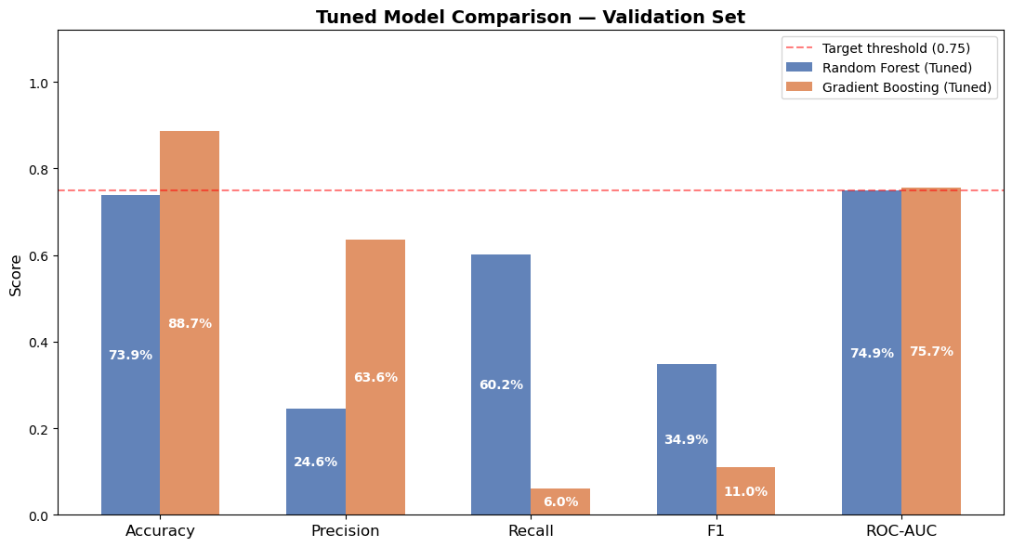
Figure 2. Tuned Model Comparison – Validation Set

- Test Set Evaluation
  - Metrics
On the test set, the tuned Gradient Boosting model achieved accuracy of 0.887 and ROC-AUC of 0.762, demonstrating strong ability to rank borrowers by default risk. Precision was 0.622, while recall was low at 0.061, resulting in an F1-score of 0.111, reflecting difficulty in detecting default cases due to class imbalance.
  - Error Analysis
Most false negatives were borrowers with high income and moderate credit scores, and their predicted default probabilities clustered around 0.19. This suggests that adjusting the classification threshold could improve recall for high-risk borrowers.
  - Feature Importance
The features contributing most to default prediction were:
- LoanToIncomeRatio
- CreditDTIRisk
- MonthlyInterestBurden
- IncomePerCreditLine
- CreditScore
These engineered financial metrics are critical for model interpretability and support risk-based decision-making.
- Deployment Consideration

  - Risk Management
Deploy the model to provide predicted probabilities that rank borrowers by default risk, rather than relying solely on binary classification. Integrate these risk scores into loan origination workflows to support credit officers and apply dynamic thresholds or business rules to flag high-risk applicants and increase recall where necessary.

  - Monitoring and Compliance
Continuously track key performance metrics (ROC-AUC, recall, F1) to detect model drift and retrain periodically with new loan data. Leverage engineered features and feature importance reports to maintain transparency, support explainability, and ensure compliance with regulatory requirements.

- Limitations
The model’s low recall limits its ability to detect default cases, which may reduce the effectiveness of early-warning systems, and adjusting thresholds to improve recall could increase false positives. Regulatory requirements for explainability mean that some feature interactions in ensemble models may remain difficult to interpret. Additionally, model performance may degrade over time without continuous monitoring and retraining, as borrower behavior and economic conditions evolve.
- Future Work
Future work should focus on both enhancing data inputs and improving modeling approaches. Additional borrower and loan features, such as credit utilization trends, prior default history, debt to income trajectory, and employment stability, could be integrated to improve predictive power. Incorporating macroeconomic indicators and repayment patterns may also capture broader risk factors. On the modeling side, techniques such as resampling and cost sensitive learning could improve recall for minority class defaults and overall predictive performance. Furthermore, threshold optimization strategies can be explored to minimize expected financial loss rather than relying solely on standard classification metrics.

